**Project Design Phase-II**

**Data Flow Diagram & User Stories**

|  |  |
| --- | --- |
| **Date** | 03 October 2022 |
| **Team ID** | PNT2022TMID42383 |
| **Project Name** | Real - Time Communication System Powered By AI for Specially Abled |
| **Maximum Marks** | 4 Marks |

**Data Flow Diagrams:**

A Data Flow Diagram (DFD) is a traditional visual representation of the information flows within a system. A neat and clear DFD can depict the right amount of the system requirement graphically. It shows how data enters and leaves the system, what changes the information, and where data is stored.

Example: DFD Level 0 (Industry Standard)

**Example:** [**(Simplified)**](https://developer.ibm.com/patterns/visualize-unstructured-text/)

**](https://developer.ibm.com/patterns/visualize-unstructured-text/)**

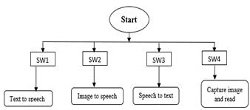

Data flow diagram of the proposed model

|  |  |
| --- | --- |
|  |  |
| Data flow diagram of the text-to-speech | Data flow diagram of the image-to-speech |

|  |  |
| --- | --- |
| Call speechtotext()    Open browser and  connect to  speechtexter.com    I/P to microphone    Speak now    Recognize the src    Is  the  voic  Clear    Error    Print  Didn’t catch  voice    Data flow diagram of the speech-to-text | Capture image  and read    Crop useful portion    Convert RGB to grey  scale image    Blur image using gaussian fx  ”    Pass to threshold fx” to get  highlighted img    Find contours and  obj of img    Find angles less  than 90degree    Count no. of angles    Keyboard interrupt    Print goodbye    Find defects and edges    Data flow diagram of the image-to-text |
|  |  |

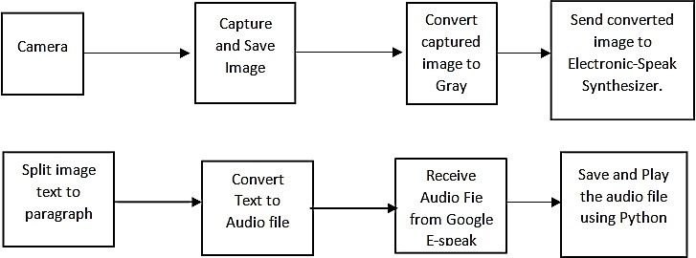

Block diagram for text-to-speech conversion using camera.

**User Stories**

Use the below template to list all the user stories for the product.

|  |  |  |  |  |  |  |
| --- | --- | --- | --- | --- | --- | --- |
| **User Type** | **Functional**  **Requirement (Epic)** | **User Story**  **Number** | **User Story / Task** | **Acceptance criteria** | **Priority** | **Release** |
| Customer  (Mobile user) | Registration | USN-1 | As a user, I can register for the application by entering my email, password, and confirming my password. | I can access my account / dashboard. | High | Sprint-1 |
|  |  | USN-2 | As a user, I will receive confirmation email once I have registered for the application. | I can receive confirmation email & click confirm. | High | Sprint-1 |
|  |  | USN-3 | As a user, I can register for the application through Facebook. | I can register & access the dashboard with Facebook Login. | Low | Sprint-2 |
|  |  | USN-4 | As a user, I can register for the application through Gmail. | I can register the application using gmail with details linked to the gmail. | Medium | Sprint-1 |
|  | Login | USN-5 | As a user, I can log into the application by entering email & password. | Can enter these credentials either by manual or by auto filling depends on the case. | High | Sprint-1 |
|  | Dashboard | USN-6 | As a user, I want to know about my data which I have given to see them visually appealing. | Can see the user data after successfully logging onto the application. | Medium | Sprint-1 |
| Customer (Web user) | Registration | USN-7 | As a User, I can register for the application through web by entering mobile number / gmail, password and confirming it. | I can access my account / dashboard through web. | High | Sprint-1 |
| Customer Care Executive |  | USN-8 | As a user , I Can get any support if needed by dialing the call or clicking the support. | After completing the registration the user can avail this service. | Medium | Sprint-1 |
| Administrator |  | USN-9 | The company should take care of the admin functionalities. | Admin should have access to each information registered by the user. | High | Sprint-1 |
| Sign Up |  | USN-10 | As a User, I should need to sign up if I don’t haven’t registered for the account earlier. | The credentials used for signing up should be unique.It is not used by | High | Sprint-1 |

|  |  |  |  |  |  |  |
| --- | --- | --- | --- | --- | --- | --- |
| **User Type** | **Functional**  **Requirement (Epic)** | **User Story**  **Number** | **User Story / Task** | **Acceptance criteria** | **Priority** | **Release** |
|  |  |  |  | any other users. |  |  |
| Wishlist |  | USN-11 | As a user, I am before avail for the service which can be kept aside. | As a User, I can review and use the services if needed. | Low | Sprint-2 |
| Enrolled |  | USN-12 | As a user, I can use the service after enrolling.So that the user can know and use. | As a user, it is quite appealing. | Low | Sprint-2 |